|  |  |
| --- | --- |
| **Exp No: 8**  **Date: 22.04.25** | **LIBRARY MANAGEMENT SYSTEM** |

**AIM:**

Write a program to implement a library management system

**PROGRAM:**

**LIBRARAYMANAGAEMENT.JSP**

<%@ page import="java.sql.*" %>  
<%@ page contentType="text/html;charset=UTF-8" language="java" %>  
<html>  
<head>  
  <title>Library Management - Add Book</title>  
  <style>  
  body {  
    font-family: Arial, sans-serif;  
    background-color: #f3f3f3;  
    margin: 20px;  
    padding: 20px;  
  }  
  
  h2 {  
    color: #333;  
  }  
  
  form {  
    background-color: #fff;  
    padding: 20px;  
    border-radius: 8px;  
    box-shadow: 0 2px 5px rgba(0,0,0,0.1);  
    width: 400px;  
  }  
  
  input[type="text"],  
  input[type="number"],  
  select {  
    width: 100%;  
    padding: 8px;  
    margin: 6px 0 12px 0;  
    border: 1px solid #ccc;  
    border-radius: 4px;  
  }  
  
  input[type="submit"] {  
    background-color: #4CAF50;  
    color: white;  
    border: none;  
    padding: 10px 16px;  
    cursor: pointer;  
    border-radius: 4px;  
  }  
  
  input[type="submit"]:hover {  
    background-color: #45a049;  
  }  
  
  p {  
    font-size: 16px;  
  }  
  
  a {  
    color: #007BFF;  
    text-decoration: none;  
  }  
  
  a:hover {  
    text-decoration: underline;  
  }  
</style>  
  
  <script>  
  
    function validateForm() {  
      const bookId = document.getElementById("bookId").value.trim();  
      const title = document.getElementById("title").value.trim();  
      const author = document.getElementById("author").value.trim();  
      const year = document.getElementById("year").value.trim();  
      const category = document.getElementById("category").value;  
      const copies = document.getElementById("copies").value.trim();  
      const currentYear = new Date().getFullYear();  
  
      if (!/^[a-zA-Z0-9]+$/.test(bookId)) {  
        alert("Book ID must be alphanumeric.");  
        return false;  
      }  
      if (!/^[A-Za-z ]+$/.test(title)) {  
        alert("Title must contain only letters.");  
        return false;  
      }  
      if (!/^[A-Za-z ]+$/.test(author)) {  
        alert("Author name must contain only letters.");  
        return false;  
      }  
      if (!/^\d{4}$/.test(year) || parseInt(year) > currentYear) {  
        alert("Year must be a valid 4-digit year.");  
        return false;  
      }  
  
      if (category === "") {  
        alert("Please select a category.");  
        return false;  
      }  
      if (isNaN(copies) || parseInt(copies) <= 0) {  
        alert("Copies must be a positive number.");  
        return false;  
      }  
  
      return true;  
    }  
  </script>  
</head>  
<body>  
  <h2>Add Book to Library</h2>  
  <form method="post" onsubmit="return validateForm()">  
    Book ID: <input type="text" name="bookId" id="bookId"/><br/>  
    Title: <input type="text" name="title" id="title"/><br/>  
    Author: <input type="text" name="author" id="author"/><br/>  
    Year: <input type="text" name="year" id="year"/><br/>  
    Category:  
    <select name="category" id="category">  
      <option value="">--Select--</option>  
      <option value="Science">Science</option>  
      <option value="Fiction">Fiction</option>  
      <option value="History">History</option>  
    </select><br/>  
    Copies: <input type="number" name="copies" id="copies"/><br/><br/>  
    <input type="submit" value="Add Book"/>  
  
    <p>  
    <label>Book Details:-</label>  
    <a href="./display_books.jsp">Click Here</a>  
    </p>  
  </form>  
  
  <%  
  
    // JSP Database logic  
  
// TODO:Change password before run the code  
// TODO: CREATE THE TABLE IN MYSQL  
/**  
CREATE TABLE books (  
  book_id VARCHAR(20) PRIMARY KEY,  
  title VARCHAR(100),  
  author VARCHAR(100),  
  year INT,  
  category VARCHAR(50),  
  copies INT  
);  
**/  
  
    String bookId = request.getParameter("bookId");  
    if (bookId != null) {  
      String title = request.getParameter("title");  
      String author = request.getParameter("author");  
      String year = request.getParameter("year");  
      String isbn = request.getParameter("isbn");  
      String category = request.getParameter("category");  
      String copies = request.getParameter("copies");  
  
      try {  
        Class.forName("com.mysql.cj.jdbc.Driver");  
        Connection conn = DriverManager.getConnection(  
          "jdbc:mysql://localhost:3306/library_management_sachin", "root", "");  
        PreparedStatement ps = conn.prepareStatement(  
          "INSERT INTO books (book_id, title, author, year, category, copies) VALUES (?, ?, ?, ?, ?, ?)");  
        ps.setString(1, bookId);  
        ps.setString(2, title);  
        ps.setString(3, author);  
        ps.setInt(4, Integer.parseInt(year));  
        ps.setString(5, category);  
        ps.setInt(6, Integer.parseInt(copies));  
  
        int result = ps.executeUpdate();  
        if (result > 0) {  
         %>  
         <script>alert("Book Added Successfully!!")</script>  
         <%  
        } else {  
        %>  
             <script>alert("Failed to add book!!")</script>  
             <%  
          out.println("<p style='color:red;'>Failed to add book.</p>");  
        }  
  
        ps.close();  
        conn.close();  
      } catch (Exception e) {  
        out.println("<p style='color:red;'>Error: " + e.getMessage() + "</p>");  
      }  
    }  
  %>  
</body>  
</html>

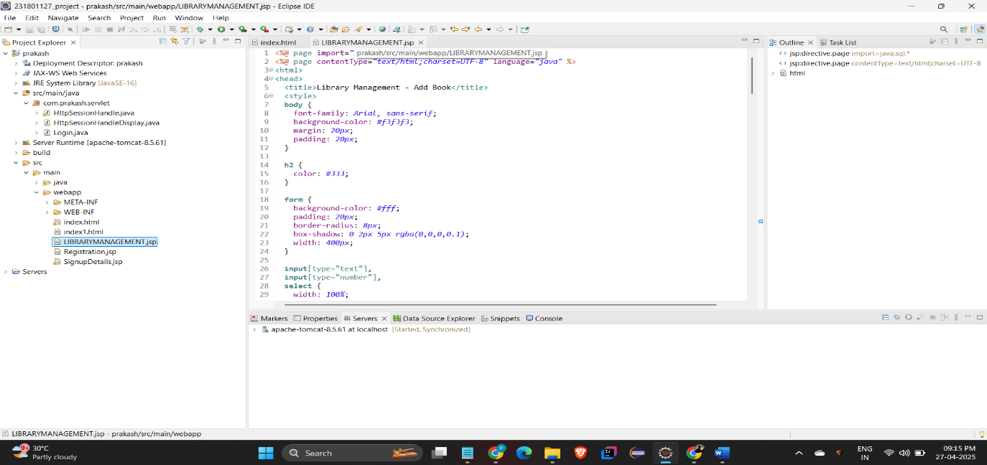

**OUTPUT:**

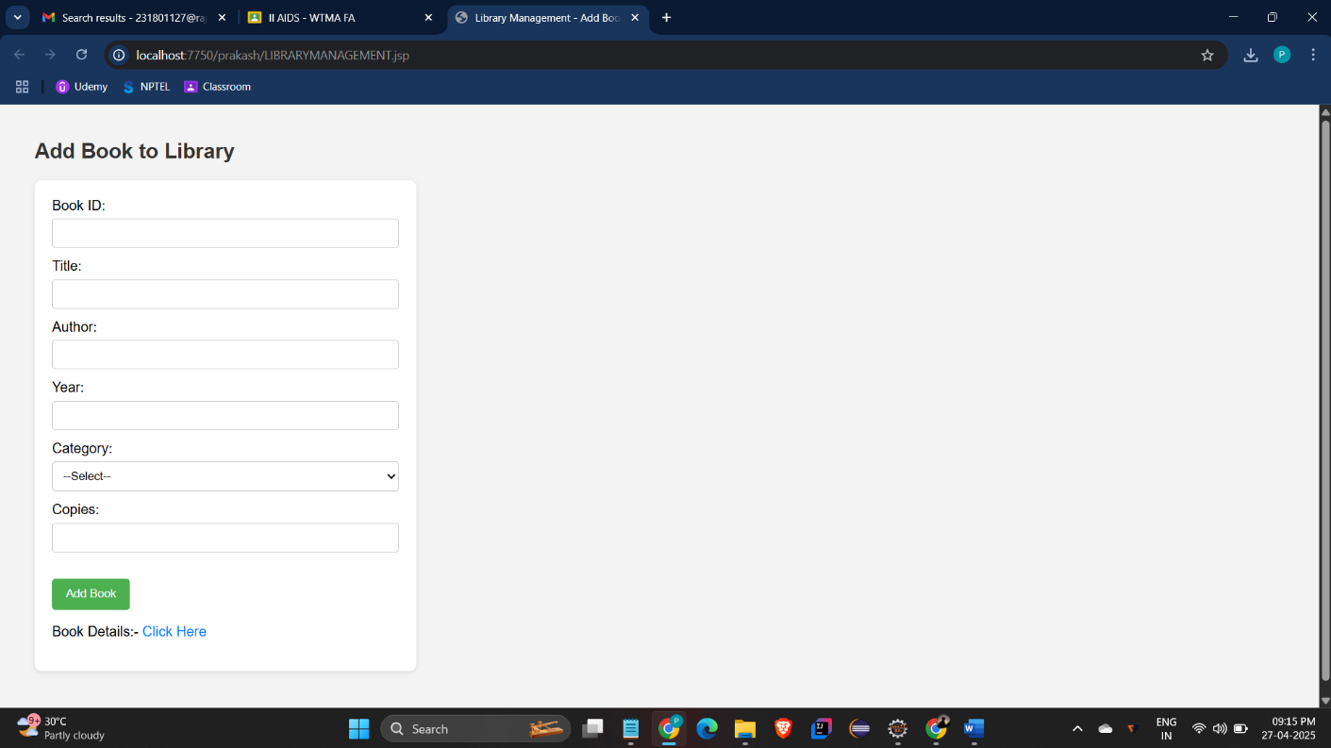

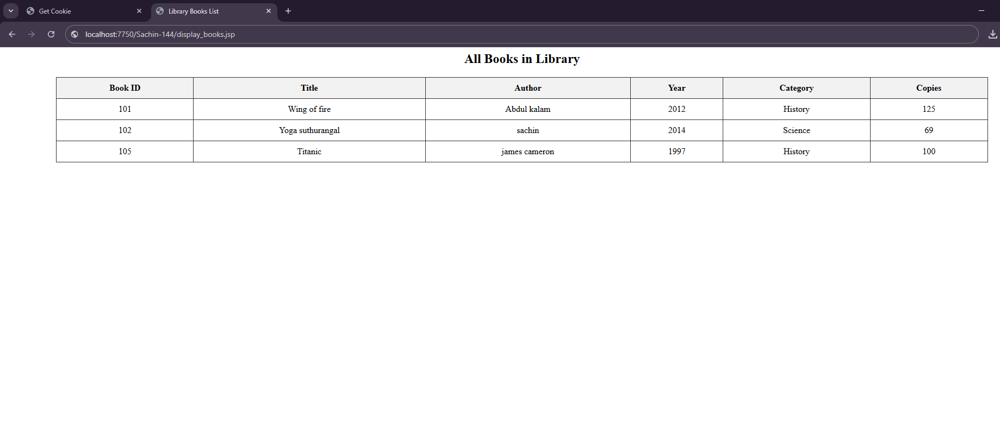

**RESULT :**Thus the experiment to implement the library management system has been successfully implemented and verified